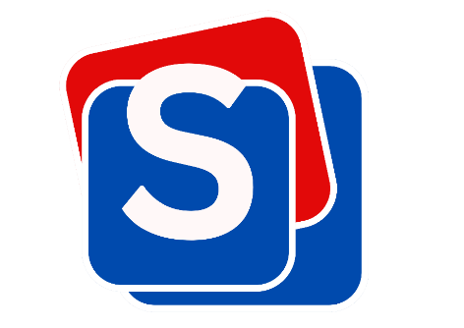
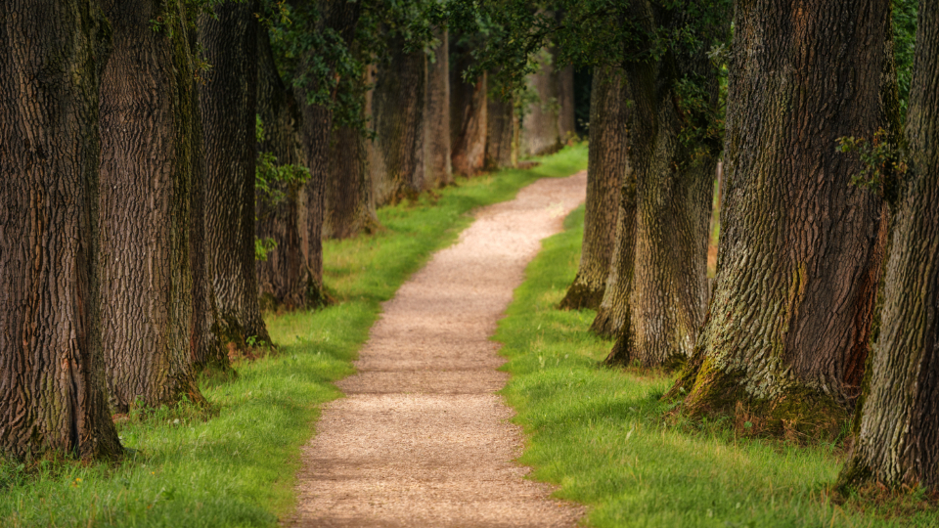

Djanogly Sherwood Academy

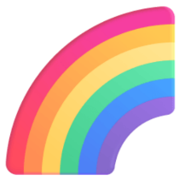






Important Dates
Every Thursday - PE
Monday 4th May
- Bank Holiday (no school)
Wednesday 6th May - Greek Day at Wollaton Hall
Friday 22nd May - Last day of half-term

History - We will be learning about the Ancient Greeks. We will find out about important aspects of their society, such as democracy and the Olympic Games, and explore their impact on life in modern times.
Science - We will be learning about how plants grow.
DT - We will be learning about pneumatic systems.
Computing - We will be learning how to write and debug algorithms.
RE - We will be learning about what it means to go on a pilgrimage and the specific places different religions go to on pilgrimage.
Spanish - We will be learning verbs for different activities and how to say I know how and I don’t know how.
Maths
In Year 3, we will be learning about fractions, mass and capacity. In Year 4, we will be learning about length and perimeter, continuing our knoweldge on decimals and focusing on money.
English
Children will be designing a house of the future and writing a report to describe its features. We will be revising writing in paragraphs, using noun phrases, prepositions, conjunctions and adverbs. We will also focus on apostrophes for possession.
Welcome to Summer 1:
Pioneers
#sherwoodbuzz
@djanoglysherwood
@sherwoodacad

