
m
Djanogly Sherwood Academy LKS2 Summer 1 - Homework – Pioneers – LKS2


Homework helps us to consolidate our understanding, as well as helping us to become organised and independent.

Homework Challenges
Read at least three times per week.
Choose from the challenges below.
Practise your Curriculum Assessment questions.
Access Reading Plus at least twice per week.
Access TT Rockstars at least twice per week.








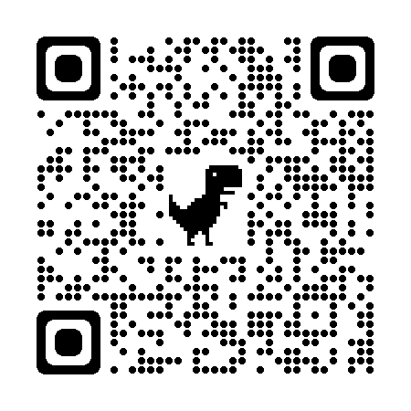
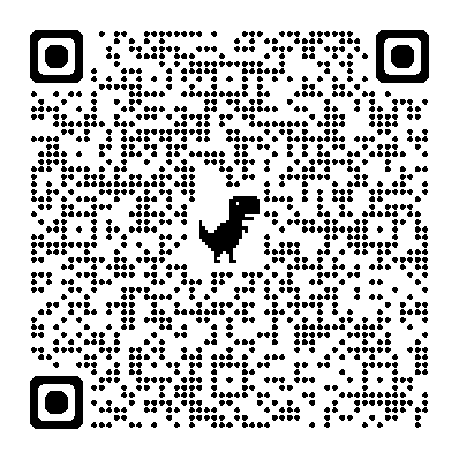
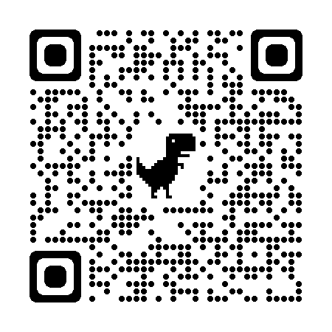


Challenge 1: Research the first Olympic games and compare them to today’s games. Present this in your own way.
Challenge 4: Complete an algorithm and test it on a friend.
Challenge 3: Research how pneumatic systems work for different toys. Present in your own way.
Challenge 2: Draw and label a plant. How does the plant transport water?
Where everyone belongs

